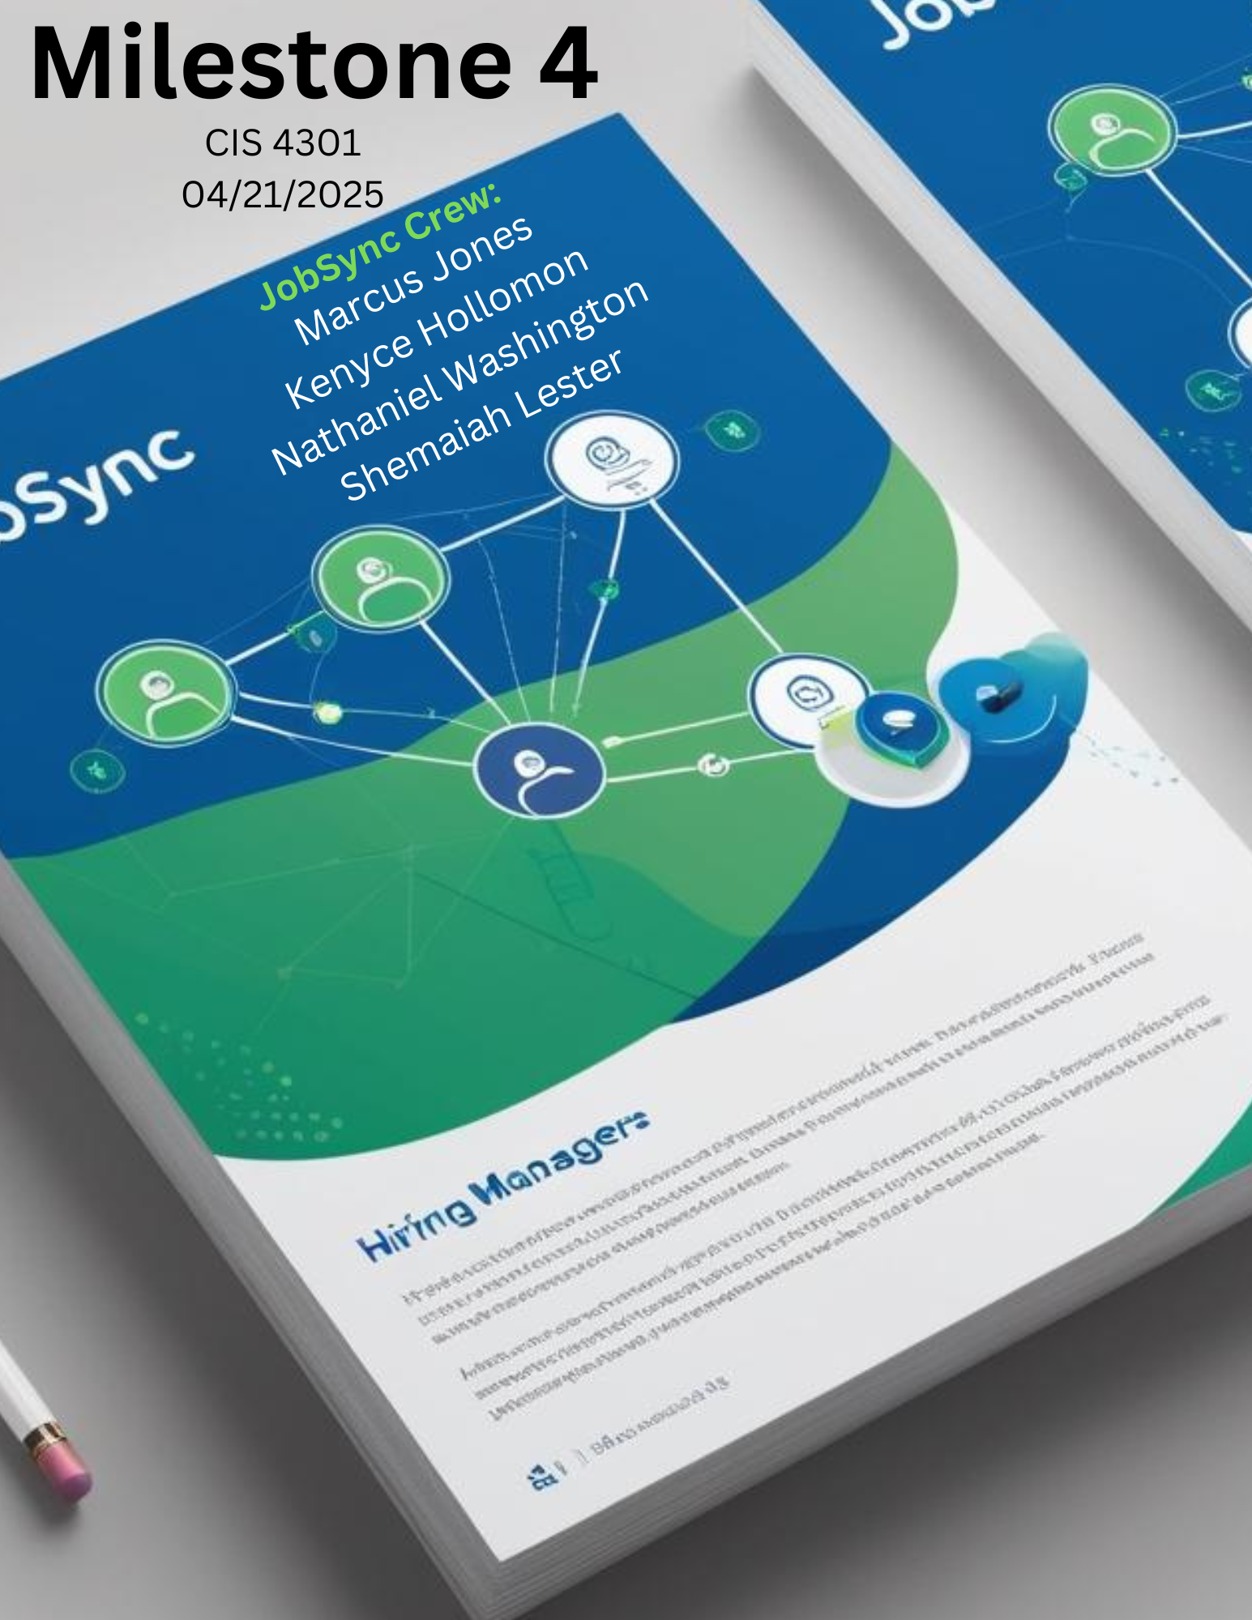

**Table of contents**

**Risk Report……………………………………………………………………………………………………………………………….3**

**Updated DFD ………………………………………………………………………………………………………………………..6**

**Collection Relationship Diagram………………………………………………………………………………………………..7**

**Data Dictionary………………………………………………………………………………………………………………………..13**

**Lesson Learned……………………………………………………………………………………………………………………….18**

**Poster Presentation………………………………………………………………………………………………………………19**

**Pre-recorded Presentation……………………………………………………………………………………………………20**

**Risk report**

|  |  |  |
| --- | --- | --- |
| **Category** | **Hurt (Impact)** | **Root Cause** |
| Technical | Missed deadlines, reduced functionality | Complex AI models and a lack of skilled resources |
| Data | Mismatched jobs, bad user experience | Inconsistent data from APIs |
| Legal/Security | User trust loss, legal action | Insecure data storage or poor access control |
| Product/UX | Poor retention, low ROI | Lack of onboarding, confusing UI |
| Operational | Missed opportunities for users | Unclear expectations or tool limitations |
| Functional | Reduced candidate confidence | Poor model training or outdated content |
| Financial | Project delay or scope cuts | Underestimating costs or overspending |
| Technical | Loss of user base | Inadequate testing on platforms |
| Legal/Ethical | Compliance issues | Misuse or misinterpretation of AI recommendations |
| Technical | Bad UX, user drop-off | Weak backend scalability |
| Functional | User frustration, low app trust | Weak ML training data or biases |
| Strategic | Limited job opportunities | Weak B2B outreach or unclear value proposition |
| Reputational | Slowed user growth | Miscommunication or bugs |
| Technical | Poor UX, broken workflows | Rushed development, poor planning |
| Ethical | Brand damage, user distrust | Lack of diverse training data |
|  |  |  |
|  |  |  |
| Functional | User frustration due to incorrect suggestions | Variability in resume formats |
| Technical | Platform failures occur if external APIs fail | Over-reliance on external services |
| Operational | Productivity loss, increased errors | High pressure and unrealistic goals |
| Product/UX | Drop in feature usage | Poor explanation/tutorials |
| Financial | Project discontinuation or feature cuts | Weak investor interest or revenue |

|  |  |  |
| --- | --- | --- |
| **Triggers** | **Potential Response** | **Risk Owner** |
| Missed sprints, incomplete modules | Add buffer time, modular design, hire experienced developers | Tech Lead |
| Low job relevance in user results | Use validation layers, pull from multiple sources | Data Engineer |
| Data leaks, unauthorized access | Implement encryption, follow GDPR, security audits | Security Lead |
| Low daily/weekly active users | Early user testing, improve UI/UX, strong marketing | Product Manager |
| No responses from employers | Employer onboarding, AI summaries, scheduled check-ins | Partnerships Lead |
| User complaints, low success rates | Real-time updates, human validation, industry research | AI/UX Designer |
| Funding gaps, overspend alerts | Track budget regularly, prioritize must-haves | Project Manager |
| Crashes, layout bugs reported | Cross-platform testing, responsive design | QA Lead |
| Legal reviews, complaints | Consult legal team, transparent disclaimers | Legal Advisor |
| Slow performance, 500 errors | Use scalable cloud services, conduct load tests | DevOps Engineer |
| Poor job recommendations | Continuous training, user feedback loop | AI Engineer |
| Low sign-up rate from employers | Improve partner incentives, clearer pitch | Business Development Lead |
| Social media backlash, low app ratings | PR plan, fast customer support response | Marketing Manager |
| Errors, missing features at launch | Feature freeze policy, proper testing | Project Manager |
| Disproportionate outcomes for certain users | Regular bias audits, human-in-the-loop reviews | Ethics & Compliance Officer |
|  |  |  |
|  |  |  |
| Users reporting mismatched suggestions | Use standardized resume templates, improve parsing logic | AI Product Owner |
| Third-party outage, data loss | Fallback systems, API monitoring, local caching | Integration Engineer |
| Decline in quality, more sick leaves | Plan buffer weeks, enforce work-life balance | Project Manager |
| Users skipping over tools | Create guided tours, tooltips, FAQ section | UX Lead |
| Budget freezes, staff reductions | Diversify funding, build clear business case | Executive Team |

|  |  |  |  |
| --- | --- | --- | --- |
|  | **Abbreviation** | **Meaning** |  |
|  | UX |  |  |
|  | AI | Artificial Intelligence |  |
|  | QA | Quality Assurance |  |
|  | GDPR | General Data Protection Regulation |  |
|  | B2B | Business-to-Business |  |
|  | ML | Machine Learning |  |
|  | SLA | Service-Level Agreement |  |
|  | **Category** | **Description** |  |
|  | Technical | Code, architecture, and system infrastructure risks. | |
|  | Functional | Feature functionality or performance risks. |  |
|  | Operational | Process, people, or communication-related risks. |  |
|  | Legal/Security | Privacy, compliance, or cybersecurity concerns. |  |
|  | Product/UX | User experience and design risks. |  |
|  | Financial | Cost and budget-related risks. |  |
|  | Strategic | Growth strategy and market risks. |  |
|  | Reputational | Brand image and public perception risks. |  |
|  | Ethical | AI fairness, inclusivity, and ethical use. |  |
|  |  |  |  |
|  |  |  |  |
|  | **Rank** | **Meaning** |  |
|  | Low | Minor impact; manageable without major changes. | |
|  | Medium | Noticeable impact; needs tracking and a response. | |
|  | High | Major disruption; needs proactive mitigation. |  |
|  | Critical | Severe impact; could jeopardize the entire project. | |

**Updated DFD**

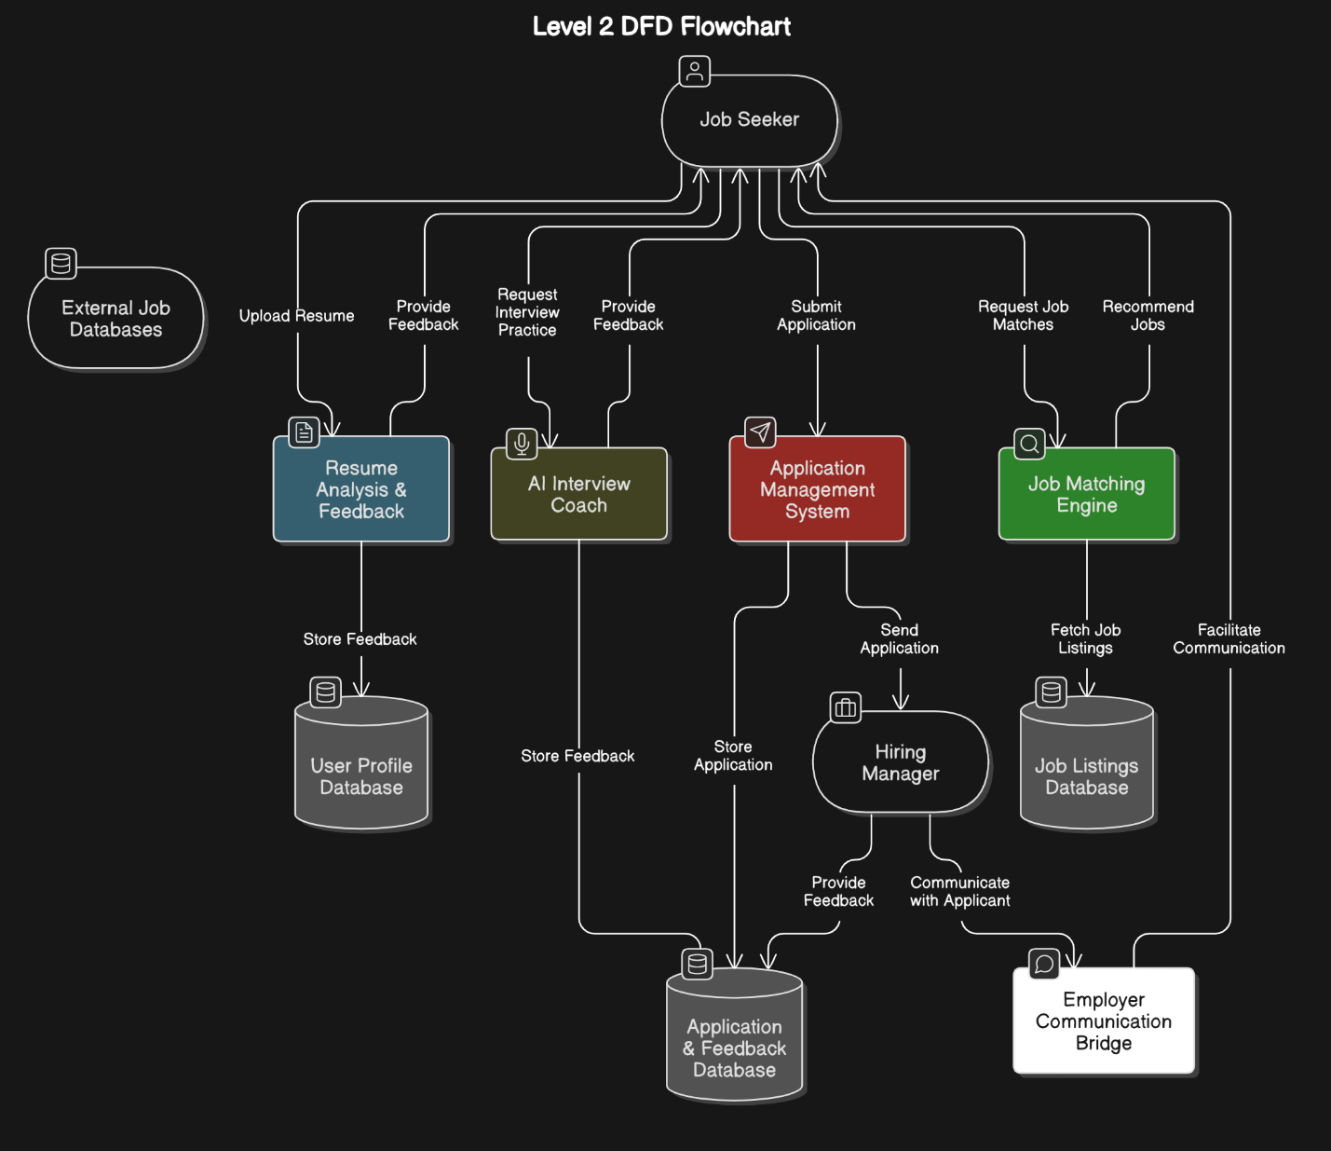

**JobSync – Collection Relationship Diagram (CRD)**

**Collections:**

1. **Users**
2. **Employers**
3. **JobPostings**
4. **Applications**
5. **SavedJobs**

**🔄 Relationships:**

* A **User** can apply to many **JobPostings**
* A **JobPosting** is created by an **Employer**
* A **User** can save many jobs via **SavedJobs**
* An **Employer** can manage multiple job postings

**1. Users Collection**

{

_id: ObjectId,

name: "Shemaiah Lester",

email: "shemaiah@example.com",

password_hash: "hashed_pw",

resume_url: "https://jobsync.com/resumes/shemaiah.pdf",

profile_summary: "CS student at FAMU, passionate about software development.",

skills: ["Python", "C++", "SQL"],

created_at: ISODate,

updated_at: ISODate

}

**2. Employers Collection**

{

_id: ObjectId,

company_name: "Johnson & Johnson",

recruiter_name: "Alicia Perez",

email: "alicia@jnj.com",

industry: "Healthcare",

company_logo_url: "https://jobsync.com/logos/jnj.png",

verified: true,

created_at: ISODate,

updated_at: ISODate

}

**3. JobPostings Collection**

{

_id: ObjectId,

employer_id: ObjectId, // Reference to Employers

title: "Automation & Controls Co-Op Intern",

description: "Assist with automation projects and data acquisition.",

location: "Remote or On-Site (New Jersey)",

requirements: ["Python", "PLC", "Data Analysis"],

salary_range: "Paid Internship",

job_type: "Internship",

deadline: ISODate("2025-05-15T00:00:00Z"),

date_posted: ISODate("2025-03-01T00:00:00Z"),

is_active: true

}

**4. Applications Collection**

{

_id: ObjectId,

user_id: ObjectId, // Reference to Users

job_id: ObjectId, // Reference to JobPostings

employer_id: ObjectId, // Denormalized for quick lookup

status: "Applied", // ["Applied", "In Review", "Interview", "Rejected", "Hired"]

applied_on: ISODate,

resume_url: "https://jobsync.com/resumes/shemaiah_applied.pdf",

cover_letter: "Excited to contribute to your team!"

}

**5. SavedJobs Collection**

{

_id: ObjectId,

user_id: ObjectId,

job_id: ObjectId,

saved_on: ISODate

}

**Data Dictionary for JobSync**

**User Collection**

|  | **Field** | **Type** | **Description** | **Constraints** |
| --- | --- | --- | --- | --- |
|  | _id | ObjectId | Unique user ID | Auto-generated |
|  | name | String | Full name of the job seeker | Required |
|  | email | String | Email for login & contact | Required, Unique |
|  | password_hash | String | Hashed password | Required |
|  | resume_url | String | Link to uploaded resume | Optional |
|  | profile_summary | String | Short bio or intro | Optional |
|  | skills | Array of Strings | Technical or soft skills | Optional |
|  | created_at | Date | Account creation date | Auto-generated |
|  | updated_at | Date | Last profile update | Auto-updated |

**Employers Collection**

|  | **Field** | **Type** | **Description** | **Constraints** |
| --- | --- | --- | --- | --- |
|  | _id | ObjectId | Unique employer ID | Auto-generated |
|  | company_name | String | Name of company | Required |
|  | recruiter_name | String | Recruiter or contact person | Optional |
|  | email | String | Contact/recruiter email | Required, Unique |
|  | industry | String | Industry type | Optional |
|  | company_logo_url | String | Company logo image URL | Optional |
|  | verified | Boolean | Admin-verified employer? | Defaults to false |
|  | created_at | Date | When profile was created | Auto-generated |
|  | updated_at | Date | Last update | Auto-updated |

**Job Postings Collection**

|  | **Field** | **Type** | **Description** | **Constraints** |
| --- | --- | --- | --- | --- |
|  | _id | ObjectId | Job post ID | Auto-generated |
|  | employer_id | ObjectId | Linked to Employers | Required |
|  | title | String | Job title | Required |
|  | description | String | Full job details | Required |
|  | location | String | Job location (e.g., remote, on-site) | Optional |
|  | requirements | Array of Strings | Skills/experience needed | Optional |
|  | salary_range | String | Salary or "Unpaid"/"Stipend" | Optional |
|  | job_type | String | ["Internship", "Part-Time", "Full-Time"] | Required |
|  | deadline | Date | Application deadline | Optional |
|  | date_posted | Date | Posted on | Auto-generated |
|  | is_active | Boolean | Is job still accepting applications? | Defaults to true |

**Job Application Collection**

|  | **Field** | **Type** | **Description** | **Constraints** |
| --- | --- | --- | --- | --- |
|  | _id | ObjectId | Application ID | Auto-generated |
|  | user_id | ObjectId | Applicant's user ID | Required |
|  | job_id | ObjectId | The job being applied to | Required |
|  | employer_id | ObjectId | Used for faster filtering | Optional |
|  | status | String | Application status | Enum: Applied, In Review, etc. |
|  | applied_on | Date | Timestamp of submission | Auto-generated |
|  | resume_url | String | Resume used for this application | Optional |
|  | cover_letter | String | Optional cover letter text | Optional |

**Saved Jobs Collection**

|  | **Field** | **Type** | **Description** | **Constraints** |
| --- | --- | --- | --- | --- |
|  | _id | ObjectId | ID of saved job record | Auto-generated |
|  | user_id | ObjectId | Who saved the job | Required |
|  | job_id | ObjectId | Which job was saved | Required |
|  | saved_on | Date | Timestamp of save action | Auto-generated |

**5. Lessons-learned report**

**Shemaiah:** So far in this course, I have learned how information systems are developed to meet organizational needs through careful planning, analysis, design, and implementation. I’ve understood the importance of gathering accurate user requirements, creating effective data models, and documenting each development phase. A key part of the course has also been learning how crucial collaboration is, working with team members, stakeholders, and users to ensure the final system is functional, efficient, and user-friendly. Overall, I’ve gained insight into the technical and interpersonal aspects of successfully designing and developing an information system.

**Kenyce:** During my time in this course, I learned the importance of time management and communication. In addition, l learned how to breakdown a project learned how to breakdown a project into different phases using tools like the WBS, DFD’s and Risk registers. The main part of this course has been to develop and strengthen my technical skills so I can contribute more directly to complex features in future projects. Overall, this semester was a meaningful step in my career journey as I learned how to turn a product idea into a functional well thought out plan.

**Alonzo:** Overall, in the course of making this project me and the team have learned that creating an application with full functionality and integration is no easy task and requires a lot of careful planning and detailed refinement. It wasn't without it's ups and downs, for our first time ever creating an application we ran into many mental road blocks that made the process quite difficult all around. Ensuring the platform was intuitive across various devices demanded significant effort in UX/UI design and usability testing. Despite the challenges though, the project was able to reinforce the importance of a structured approach, leveraging proven design patterns and helping us maintain flexibility to adapt to unexpected hurdles.

**Nate:** All in all, over the course of designing this project I have learned that for a project to be successful you must have good team communication. I learned that breaking a project down into smaller parts can help the project get done faster, more efficiently, and in a timely manner. Also, I learned that time management is a very important factor when trying to complete a project due to team members having different schedules and things of that sort. Overall, designing this project has helped me to learn what it would be like working with a team to get a project done on a job.

**Part 6.** 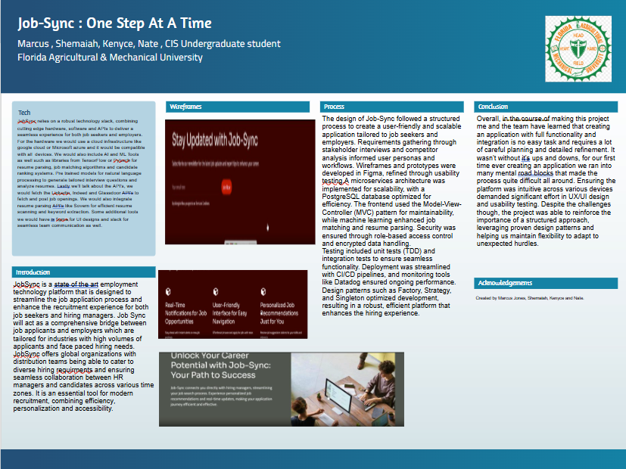

Part 7.) A VIDEO PRESENTATION FOR THE POSTER.

<https://youtu.be/iBkp3l8s4FA>